Please see in yellow below the revised times for the COVID Symposium
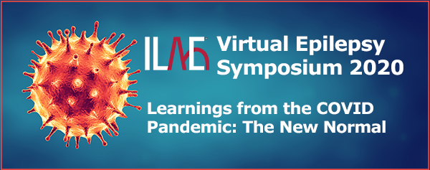

This important virtual symposium will be offered twice, so that you may choose the most convenient date and time:
Tuesday, 8 September 2020
16:00-18:00 Central European Summer Time
(10:00-12:00 EDT / 22:00–00:00 China / 23:00–01:00 Japan)
Register Here
Thursday, 10 September 2020
12:00–14:00 China; 13:00–15:00 Japan
(00:00–02:00 EDT / 06:00–08:00 CEST)
Register Here
This virtual symposium features opportunities to gain insights from ILAE experts, learn more about current best practices, and understand how the pandemic will likely affect how we support and manage patients with epilepsy into the future. It is structured to give you maximum opportunities for engagement, with three distinct components:
- Pre-symposium case exercise
When you register, you will be asked about your experiences with COVID-19 and epilepsy, and what you would like to learn. You will then be directed to an interactive patient case, where you progress from clinical examination to diagnosis and treatment.
- Virtual symposium
Panel discussions and brief presentations will be interspersed with opportunities for you to pose questions to the speakers and prompt discussion amongst the panellists on the best approaches to clinical care during the pandemic.
- Post-symposium microlearnings
Following the symposium, you will receive self-paced online microlearning modules to further help you design the best strategy for supporting and managing your patients during this pandemic.
Symposium Agenda
Introduction & overview: J Helen Cross (Chair), Julie Hall (Moderator)
Neurological implications of COVID-19 & implications on antiseizure medications (ASM): J. Helen Cross, Emilio Perucca, Samuel Wiebe
- Overview of COVID and epilepsy
- COVID, antiseizure medicines and co-morbidities in the elderly
- Dealing with complex epilepsies
Pathology: What does COVID-19 do to the brain? Ingmar Blümcke
- Images of the visible effect of COVID-19 on the brain
- Discussion about their potential clinical implications
Optimizing patient care during a pandemic: J Helen Cross, Samuel Wiebe
- Face-to-face consultations vs telemedicine/remote consultation:
  - How to deal with newly diagnosed patients and follow-up
  - Common practice vs state of the art
- What EEG services are necessary?
Learnings from the COVID-19 situation for future pandemics: Ingmar Blümcke, J Helen Cross, Emilio Perucca
- Digital transformation of learning
- What will be the New Normal?
Register now
Registration for this event is free and open to all health and care professionals.
ILAE has applied to ACCME for Continuing Medical Education (CME) points for the two hours of the Virtual Epilepsy Symposium. Further details will be available shortly.
Register Here for Tuesday, 8 September
Register Here for Thursday, 10 September

